Book

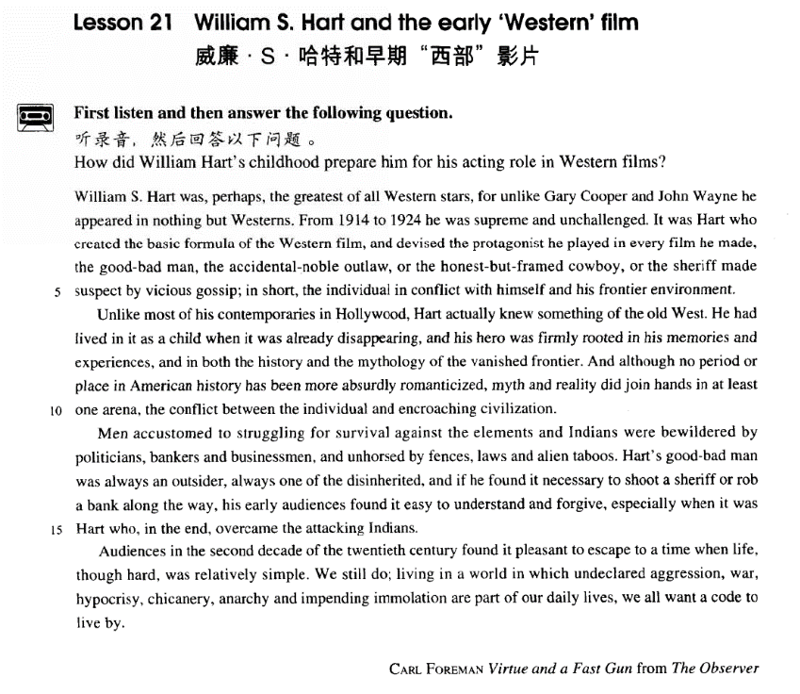

课文

William S. Hart was, perhaps, the greatest of all Western stars,

威廉.S.哈特大概是美国西部电影明星中的佼佼者。

for unlike Gary Cooper and John Wayne he appeared in nothing but Westerns.

他和加里.古柏、约翰.韦恩不同，他只在西部电影中扮演角色。

From 1914 to 1924 he was supreme and unchallenged.

在1914年至1924年期间，他首屈一指，独霸影坛。

It was Hart who created the basic formula of the Western film,

正是他创造了西部电影的基调，

and devised the protagonist he played in every film he made,

即在他自己的拍摄的影片中他所塑造的主人公形象：

the good-bad man, the accidental, noble outlaw,

被认为是坏人的好人，出人意料的高尚的逃犯，

or the honest, but framed cowboy, or the sheriff made suspect by vicious gossip;

诚实却遭陷害的牛仔或因流言蜚语蒙受嫌疑的司法官。

in short, the individual in conflict with himself and his frontier environment.

总之，主人公是一个自相矛盾，又与他的拓荒环境相矛盾的人物。

Unlike most of his contemporaries in Hollywood,

哈特与大部分同时代在好莱坞的演员不同，

Hart actually knew something of the old West.

他确实了解西部早期拓荒生活的一些情况。

He had lived in it as a child when it was already disappearing,

作为一个孩子他曾在西部生活过，当时西部拓荒生活正在消失。

and his hero was firmly rooted in his memories and experiences,

他塑造的英雄人物深深地扎根于他本人的记忆和经历之中，

and in both the history and the mythology of the vanished frontier,

也扎根于有关已经消失的拓荒生活的历史和神话之中。

And although no period or place in American history has been more absurdly romanticized,

虽然在美国历史上没有任何时期或地区像西部拓荒时期那样被荒谬地浪漫主义化了，

myth and reality did join hands in at least one arena,

但神话和事实至少在某一个舞台上共存，

the conflict between the individual and encroaching civilization.

也就是存在于个人与渐渐闯入的文明这两者的冲突之中。

Men accustomed to struggling for survival against the elements and Indians were bewildered by politicians, bankers and businessmen, and unhorsed by fences, laws and alien taboos.

习惯与大自然和印第安人作斗争以求生存的拓荒者被政客、银行家和商人搞得晕头转向，最后被圈地、尖律我外来的清规戒律所击败。

Hart's good-bad man was always an outsider, always one of the disinherited,

哈特扮演的被误为坏人的好人总是一个局外人，总是一个被剥夺继承权的人。

and if he found it necessary to shoot a sheriff or rob a bank along the way,

如果他认为在进行过程中有必要枪击一个司法官或抢劫一个银行，

his early audiences found it easy to understand and forgive,

他的早期观众很容易接受，觉得应该原谅他，

especially when it was Hart who, in the end, overcame the attacking Indians.

特别是当哈特最后战胜了前来进攻的印第安人时，观众更能原谅他。

Audiences in the second decade of the 20th century found it pleasant to escape to a time when life, though hard, was relatively simple.

生活在20世纪20年代的观众认为，逃到一个即使艰苦但比较简朴的时代中去是件愉快的事，

We still do; living in a world in which undeclared aggression, war, hypocrisy, chicanery, anarchy and impending immolation are part of our daily lives,

我们今天仍有这种感觉。如今，不宣而战的侵略、战争、虚伪、诈骗、无政府状态以及即将临头的毁灭成了我们日常生活的一部分，

we all want a code to live by.

我们都希望有一个赖以生存的行为准则。

词汇讲解

Lesson 21 William S. Hart and the early ‘Western’ film

supreme [su:'pri:m] adj. 至高无上的

supreme adj. having the highest position of power, importance or

influence（权力，重要性或影响）最大的，至高无上的the supreme commander

the Supreme Court

the Supreme People’s Court

the Intermediate People’s Court the Supreme Being

reign supreme

As a wine producer, France still reigns supreme. Love reigns supreme in her heart.

protagonist [prə'tægənɪst]

n. 主角

leading role / part

leading man leading lady

supporting role extra

stunt man stunt woman

comedian comedienne

tragedian tragedienne

framed [freimd]

adj. 遭到陷害的

frame

to frame a picture

That’s not my signature! I’ve been framed!

My name is Michael Scofield. My brother is facing the electric chair, framed for a crime he didn't commit.

set up sb.

He wasn’t guilty of the fraud. He’d been set up by his business rivals.

I didn't kill that man, Michael.

The evidence says you did.

I was set up. plant sth. on sb.

It was planted on me!

I never touched those pants.

*Which brings us back to the gun, the one you said you dumped.* It was planted. It's the only way it could have got there. *Ballistics matched to a*

*slug...* The gun was planted! It was planted! Just like the pants. mythology [mɪ'θɒlədʒi]

n. 神话

mythology myth

Greek myths Greek mythology

poem poetry

novel fiction

scene scenery

jewel jewellery (jewelry) machine machinery

table / chair … furniture

pen / pencil … stationery

trunk / suitcase … luggage / baggage

leaf foliage

vanished ['vænɪʃd]

adj. 消失了的

vanish

disappear / vanish without trace fade / fade away

As the years passed, the memories faded away.

As the music faded away the audience broke into enthusiastic applause. arena [ə'ri:nə]

n. 竞技场

Women are entering the political arena in large numbers.

造句：成功的主办奥运会将极大地提高中国在国际舞台上的形象。Successfully hosting the Olympic Games will significantly enhance China’s image in the international arena.

encroaching [ɪn'krəʊtʃɪŋ]

adj. 渐渐渗入的

encroach *on* / *upon* …

Housing developments continue to encroach *on* wildlife habitats.

造句: 中国政府和人民绝不会接受任何侵犯中国主权 (sovereignty)

的行为。

The Chinese government and people can never accept any act that encroaches upon China’s sovereignty.

infringe on …

Don’t infringe on his privacy. trespass on …

Hunters used to trespass on his fields. Trespassers will be prosecuted. invade

The Romans invaded Britain 2,000 years ago. The infected cells can invade healthy tissue. Indian ['ɪndiən]

n. 印度人；印第安人

Negro/Black

African-American/Afro-American

Eskimo Inuit

Oriental Asian

Chinese Korean Japanese

Asian-American Chinese-American Korean-American Japanese-American

bewilder [bɪ'wɪldə(r)]

v. 使不知所措，使迷惑

Big city traffic bewildered the country girl. confuse

They confused me with their conflicting advice. puzzle / perplex / baffle

The murder case still puzzled / perplexed / baffled the police. bewildered bewildering

a bewildering variety of choices

Films, videos, CDs and CD-ROMS are just some of the bewildering amount of information they will have.

Many tourists were by the city’s complicated traffic system.

(A) degraded (B) bewildered

(C) evoked (D) diverted

As an increasing number of traffic regulation schemes are devised, the poor bewildered driver finds himself diverted and forced into one-way systems which cause even greater delays than the traffic jams they are supposed to prevent.

I was constantly ill, with a baffling array of symptoms. alien ['eɪliən]

adj. 陌生的；格格不入的； 外国的；外星的

In a world that had suddenly become alien and dangerous, he was her only security.

The idea is alien *to* our religion. Luxury is alien *to* her nature. alien cultures

alien beings from another planet foreign

Jealousy is foreign *to* his nature. exotic

exotic tropical plants

I am charmed by her exotic beauty. extrinsic (to …)

They’re looking for extrinsic aid.

The question is extrinsic *to* our discussion. intrinsic

a combination of intrinsic and extrinsic factors disinherit [7dɪsɪn'herɪt]

v. 剥夺……的继承权

disinherit sb.

He has disinherited his eldest son. inherit sth. from sb.

He inherited a fortune from his grandfather. dispossess sb. of sth.

The nobles were dispossessed of their estates. deprive sb. of sth.

Some criminals are deprived of political rights. strip sb. of sth.

divest sb. of sth. hypocrisy [hɪ'pɒkrəsi]

n. 虚伪，伪善

He condemned the hypocrisy of those politicians who do one thing and say another.

sincerity

hypocritical sincere

hypocrite

The newspapers branded him (as) a hypocrite. impending [ɪm'pendɪŋ]

adj. 迫在眉睫的，即将发生的

impending / imminent

an ~ danger / disaster / threat / famine

coming upcoming

forthcoming approaching the coming year

the upcoming holiday the approaching election loom

As the day of my interview loomed, I became increasingly nervous. My birthday is fast approaching.

My birthday is coming soon. My birthday is near at hand. My birthday is coming up.

My birthday is just around the corner. code [kəʊd]

n. 密码；编码；法规，准则

a letter in code

decipher / break / crack a code

postcode (zip code) bar code

penal code traffic code code of conduct code of ethics

In searching for a subject unique to the young nation some American writers of the 19th century turned to the land itself ―the vast, largely untamed territory that stretched from the Mississippi River to the Pacific Ocean.

As settlement moved westward from the eastern seaboard, the West came to symbolize the qualities associated with that land―open, wild and full of opportunity.

Artists of all kinds found this symbol so evocative that a new genre emerged in literature and other arts: the Western. It’s mainly about life in the 19th century in the American West, especially the lives of cowboys.

In 1903, Edwin S. Porter produced a short silent film, the Great Train Robbery, whose theme, crime and retribution, became a standard of Western filmmaking for 75 years.

The western film reached the height of its popularity from 1930 to 1950. After 1950 television Westerns drew audiences away from big-screen

Westerns.

William S. Hart is noted for his insistence on realism in Westerns based on his own life in Dakota Territory. Hart directed and starred in silent movies from 1914 until 1925.

Hart was followed by the most influential of all Western filmmakers, John Ford.

Ford’s 1939 movie Stagecoach introduced John Wayne as the perfect example of the tough, taciturn Western cowboy, who became an icon of the movie Western.

In the 1950s, Western films were joined by a subcategory, the adult Western. It focused more on the psychology of the characters than on action. A classic example of the genre is High Noon, starring Gary Cooper.

In the 1970s and 1980s Westerns began to lose box-office appeal because social protest movements caused many Americans to question the cultural values presented in Westerns.

However, in the early 1990s, two Westerns won Academy Awards for best picture. One is Dances with wolves (1990), directed by Kevin Costner.

The other is Unforgiven (1992), directed by Clint Eastwood. Westerns were resurrected.

William S. Hart was, perhaps, the greatest of all Western stars, for unlike

Gary Cooper and John Wayne he appeared in *nothing but* Westerns. appear / act / perform in a film / movie

play the lead in …

John Wayne played the lead in Stagecoach. star

John Wayne starred in Stagecoach. Stagecoach starred John Wayne. co-star

Gary Cooper co-starred with Grace Kelly in High Noon. High Noon co-starred Gary Cooper and Grace Kelly. feature

The movie featured Bruce Willis. nothing but = nothing more than = only Nothing but a miracle can save her now. You are nothing but a thief.

He dismissed Bryan as nothing more than an amateur. anything but = not … at all

He is anything but a hero / stupid. all but = almost / virtually

It’s all but impossible to read his writing. The party was all but over when we came.

We could, at one time, repair ourselves—well enough, at least, to overcome all but the most instantly fatal illnesses and accidents.

supreme unchallenged

incomparable unequalled peerless be second to none

When it comes to singing, Mary is second to none.

It was Hart who created the basic formula of the Western film, and devised *the protagonist* he played in every film he made, the good-bad

man, the accidental-noble outlaw, or the honest-but-framed cowboy, or the sheriff made suspect by vicious gossip; in short, the individual in

conflict with himself and his frontier environment. it is / was … that / who(m) …

formula pl. formulas / formulae

the formula *for* a new drug / the washing powder

It is said that the nerve poison is the more primitive of the two, that the blood poison is, so to speak, a newer product from an improved formula. devise

The cartoon character Mickey Mouse was devised by Walt Disney in 1928.

conceive

come up with

Very few people come to it.

A good name hasn’t been found for it.

People don’t like climbing the stairs to get there.

She has decided to phone the ticket office.

M: what had they decided to call the stadium? W: No one has come up with a good name.

Q: What does the woman say about the stadium? Answer: (B) A good name hasn’t been found for it. fabricate / concoct

fabricate / concoct an excuse

矛盾修饰法 Oxymoron bad-good news

a cold warm embrace sick health

sweat sorrow a damned saint

a beautiful tyrant

an honorable murder

accidental incidental

incidental expenses

incidental music for the movie incidentally

suspect that … suspect sb. of doing

I suspected him of lying.

We made him monitor / king. The statistics are suspect.

vicious adj. wicked; evil; malicious a vicious circle

a virtuous circle

a malignant tumor a benign tumor

in short in sum

in summary to sum up

to summarize simply put

in conflict (with …)

As long as poor people, who in general are colored, are in conflict with

richer people, who in general are lighter skinned, there’s going to be a

constant racial conflict in the world. inflict sth. on sb.

Please don’t inflict your love on me. afflict sb.

He may never be sure where the next meal is coming from, but he is free from the thousands of anxieties which afflict other people.

Hazen and Brown's work was stimulated by the wartime need to find a cure for the fungus infections that afflicted many military personnel.

be afflicted with / by …

Although afflicted by serious eyesight problems, Alicia Alonso was one of the principal stars of the American Ballet Theater and later formed her own dance company.

contemporary counterpart

Chinese President Xi Jinping and his American counterpart Barack Obama agreed to establish a strategic partnership.

He had lived in it as a child when it was already disappearing, and his hero was firmly rooted *in* his memories and experiences, and *in* both the history and the mythology of the vanished frontier.

Hart was born in 1870, just after the end of American Civil War in 1865. After the Civil War, slavery was abolished, four trans-continent railroads were built, and American economy was rapidly developed.

Meanwhile, the Wild West was fading away. be rooted in …

The conflict in this area was rooted in history and religion. be embedded in …

be entrenched in … be ingrained in …

He always meant to go back one day, but not to stay. His roots and mine had *become too firmly embedded in* the new land.

deep-seated / deep-rooted

a deep-seated faith in god a deep-rooted bad habit inveterate

an inveterate smoker / drinker / gambler / liar

If we remain inveterate smokers, it is only because we have so often experienced the frustration that results from failure.

have its roots in … stem from … originate in …

Printing has its roots in / stems from / originates in China.

He had lived in it as a child when it was already disappearing, and his hero was firmly rooted *in* his memories and experiences, and *in* both the

history and the mythology of the vanished frontier.

Carlyle was entirely ignorant *of* what the bottle in his pocket contained, *of*

the nature of the illness from which his friend was suffering, and *of* what had previously been wrong with his wife, but a medicine that had worked so well in one form of illness would surely be of equal benefit in another, …

The adverse effects *of* the Great Leap Forward and *of* the Cultural Revolution still loom large in the minds of Chinese policy makers.

For in a university, science majors look down *on* humanities majors, foreign language majors *on* Chinese majors, Chinese majors *on*

philosophy majors, philosophy majors *on* sociology majors, and sociology majors *on* education majors. Since education majors have no one to look down on, they can only despise the professors in their own department.

*‘Fortress besieged’* by Zhongshu Qian

And although no period or place in American history has been more absurdly romanticized, myth and reality did join hands in at least one

arena, the conflict between the individual and encroaching civilization. join hands: co-exist

conflict n. clash; collision

Men accustomed to struggling *for survival* against the elements and

Indians were bewildered by politicians, bankers and businessmen, and

unhorsed by fences, laws and alien taboos. be accustomed to sth. / doing

= be used to sth. / doing

For men accustomed to eating seven-course dinners and sleeping between fine linen sheets at home, the change to the Alps must have very hard indeed.

element (earth, water, fire, air) the elements

fight / battle / struggle against the elements fight / battle / struggle against the odds

They would have continued to struggle against economic odds and would have lived in obscurity.

unhorse vt. 使下马

Hart's good-bad man was always an outsider, always one of the disinherited, and if he found it necessary to shoot a sheriff or rob a bank

along the way, his early audiences found it easy to understand and forgive, especially when it was Hart who, in the end, overcame the attacking Indians.

Audiences *in the second decade of the twentieth century* found it pleasant

to escape to a time when life, *though hard*, was relatively simple. decade

century millennium

We still do; living in a world in which undeclared aggression, war,

hypocrisy, chicanery, anarchy and impending immolation are part of our

daily lives, we all want a code to live by.

We still find it pleasant to escape to a time when life, though hard, was

relatively simple. live by …

I have always tried to live by my faith.